**Year 9 Physics Test Revision Name:**

A laser strikes a mirror at an angle of incidence of 45˚ … What is the angle of **reflection? _________**

A laser strikes a **glass block** at an angle of incidence of 45˚ … What happens to the light as it goes through the block? _____________________________  
  
_____________________________  
  
_____________________________

**Heat Transfer**

Colour the **convection** examples yellow, the **radiation** examples red and the **conduction** examples orange.

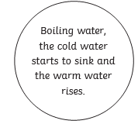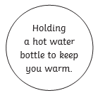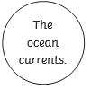

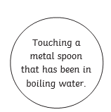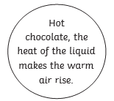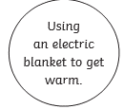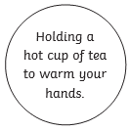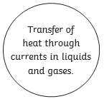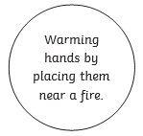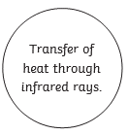

Each star achieved = 1 house point

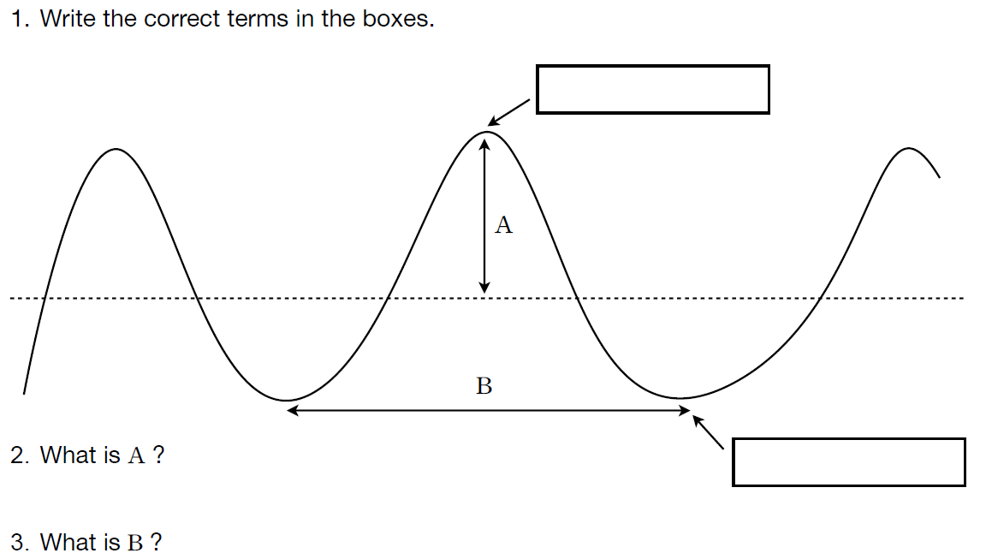

**Longitudinal and Transverse Waves:**

In **Longitudinal Waves**, the vibrations are **parallel** to the direction of wave travel

An example of a longitudinal wave is a **SOUND WAVE**.

In **Transverse waves**, the vibrations are at right angles to the direction of wave travel.

An example of a transverse wave is **LIGHT**

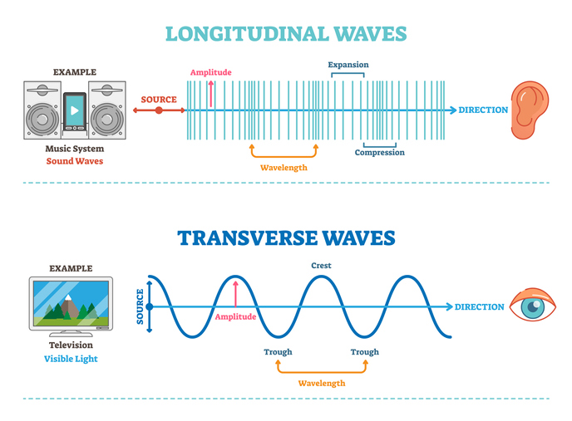

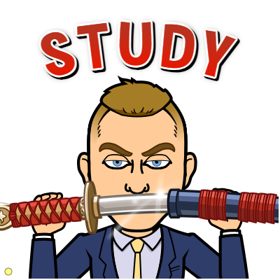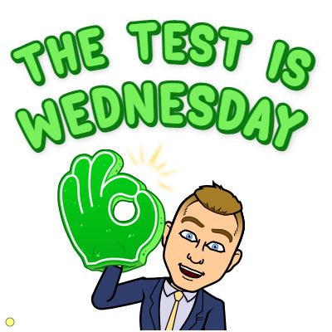

For each of the statements below tick the box that best completes the sentence.

a. Sound travels faster in a …

Solid 

Liquid 

b. Sound cannot travel through a vacuum because …

There are no particles 

The particles are too close together 

In the movie *Star Wars* the Empires Death Star explodes and the explosion is heard as the Rebel Alliance ships escape. Given what you now know, could this occur? Under what conditions could you hear an explosion in a galaxy far, far away?



**Match up the words with their correct definition.**





In 1826, a historic experiment was carried out on Lake Geneva. Two boats were moored 13 500 metres apart. One carried a 70 kg bell (below the water) and a small tray of gunpowder.

The gunpowder was ignited just as a hammer struck the bell. An observer in the second boat was able to see the flash from the gunpowder and, by using an ear trumpet, to hear the sound of the bell. He started his stopwatch when he saw the flash and stopped it when he heard the sound in the ear trumpet.

1. What was being measured in this experiment?

………………………………………………………………………………………………………………………………………..

2. Do you think the results would be accurate?

………………………………………………………………………………………………………………………………………..

3. How does the distance between the boats affect the time it took for the listener to hear the explosion?   
Did this affect the results of the experiment?

………………………………………………………………………………………………………………………………………… ………………………………………………………………………………………………………………………………………… …………………………………………………………………………………………………………………………………………

_____________________________________________________________________  
  
_____________________________________________________________________  
  
_____________________________________________________________________  
  
_____________________________________________________________________  
  
_____________________________________________________________________  
  
_____________________________________________________________________  
  
____________________________________________________________

**Visible Light**

**White light is a combination of all colours in the colour spectrum. When split with a prism, what colours do we see?**

**R  
O  
Y  
G  
B  
I  
V**

**Explain: Why do leaves appear green?  
  
____________________________________________________________  
  
____________________________________________________________  
  
____________________________________________________________**

**Explain: Why does dark blue bitumen become unbearably hot to touch after a hot and sunny summer’s day, yet pale grey concrete does not?  
  
____________________________________________________________  
  
____________________________________________________________  
  
____________________________________________________________  
  
____________________________________________________________**

The Electromagnetic Spectrum



**Radio Waves Microwaves**

**Ultra Violet X-Rays**

**Visible Light**

**Gamma Rays**

**Infra-red**

**High Energy/High Frequency**

**Low Energy/Low Frequency**

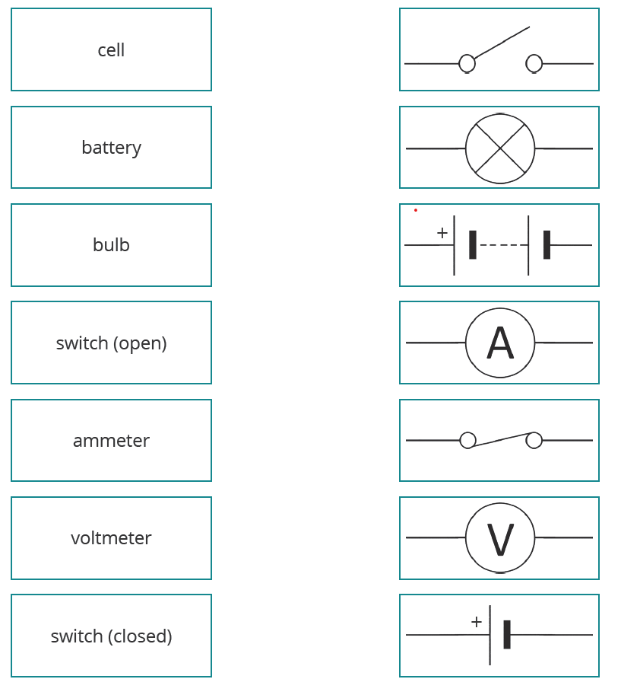

**Can you draw the following circuits?**

**C) 1 cell with two lamps in parallel**

1. **2 lamps in series with an ammeter and one cell**

**D) 1 cell with three lamps in parallel, a switch, and am ammeter**

1. **1 cell with one lamp and a switch with a voltmeter**